Easter Exercise Challenge!

During this holiday, why not try the Easter Exercise Challenge! Each day, to help you keep fit and stay healthy, try to ensure you spend at least 60 minutes being active. This requires you to move about and it should make you breath faster and get warmer.

Use the ‘Personal Diary Sheet’ to keep a record of your physical activities like skipping in the garden or riding a bike, going swimming or playing games with family and/or friends - perhaps in a park, roller skating at a disco or training/playing with a local organised sports club e.g. football, rugby, tennis, gymnastics, dance, horse riding, etc.

Even if you are stuck indoors, you can still exercise and to help you keep active here are some useful websites:

- Train like a Jedi on:
https://campaignresources.phe.gov.uk/schools/topics/ being-active/resources

- Move and dance along with:
https://www.gonoodle.com/

- Move while learning with the BBC Super Movers at:
https://www.bbc.co.uk/sport/football/supermovers

Every child who completes this challenge, and returns their named diary sheet to their Class Teacher on Tuesday 23rd April 2019 (accurately filled in for each day of the holiday) with at least 60 minutes of daily activities performed and verified by a parent signature, will achieve two Merit Points. For children who do not manage keeping active every day, but do complete over half of this challenge, they will achieve one Merit Point.

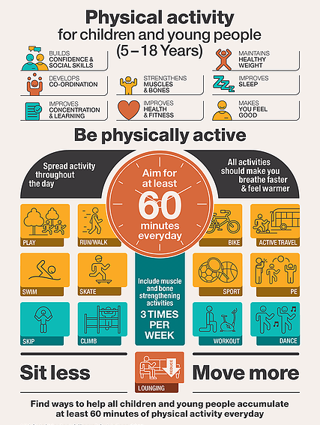

Personal Diary Sheet for

Name: _________________ Class: _________

Easter Exercise Challenge!

Date: | Activity: |  |  | Time Spent: | Parent Signature:
Saturday
6/4/19
Sunday
7/4/19
Monday
8/4/19
Tuesday
9/4/19
Wednesday
10/4/19
Thursday
11/4/19
Friday
12/4/19
Date: | Activity: |  |  | Time Spent: | Parent Signature:
Saturday
13/4/19
Sunday
14/4/19
Monday
15/4/19
Tuesday
16/4/19
Wednesday
17/4/19
Thursday
18/4/19
Friday
19/4/19
Saturday
20/4/19
Sunday
21/4/19
Monday
22/4/19
Well done! Keep active!

