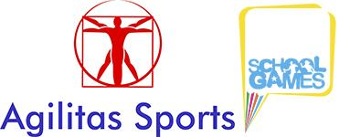
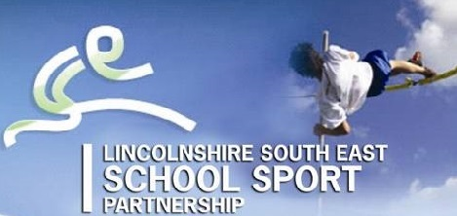

School Games
Lincolnshire South East – Boccia Competition 2017-18
On Tuesday 19th September we held our first School Games event of the year - Boccia (pronounced bot-cha).
Boccia is a Paralympic sport and a target game similar to bowls which is great for all ages and abilities. Schools were invited to send teams of 3 made up from any pupils with physical disabilities. 4 teams took part from The Priory School, Spalding Academy and The Willoughby School.
Chris Allen and Sports Leaders from Spalding Priory School taught the pupils how to play and gave them some practice games before the competition began.
School Games Organiser, Rupert Gibson, was delighted with how the event went, “this competition highlights all that is great about the School Games. Sports Leaders getting a chance to volunteer and lead and young pupils learning a new sport, competing and representing their schools (many for the first time ever). MANY thanks to Spalding Priory for hosting the event”.
Results
- 4th The Priory A Team
- 3rd Spalding Academy
- 2nd The Priory 1st Team
- 1st The Willoughby School

For forthcoming School Game events please see www.agilitassports.com

