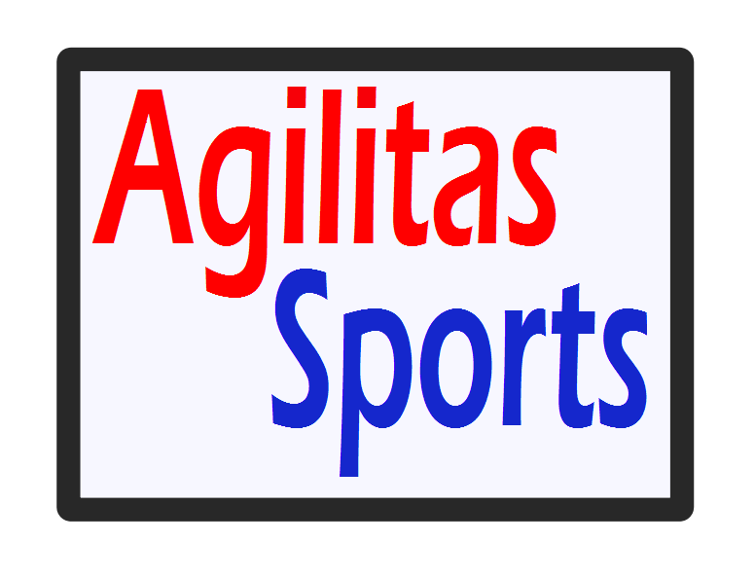
Agilitas Sports Ltd
Guidance for the use of photography
- If taking photos you must agree to these guidelines and wear identification.

- Where possible ask the child for permission prior to being photographed (not always possible for group action shots).

- Parents should try and limit their photography to their own children.

- Where possible do not include the name of a child whose image is being used.

- If naming a child or group of children in an image, only use their first names, as this will reduce the risk of inappropriate, unsolicited attention from people within and outside the sport.

- Avoid the inclusion of any other detailed information about individual children.

- Schools have already been informed that photography will be permitted. They have been asked to make us aware of any children who do not have parental permission to be photographed. We will indicate any such child with a small red circle sticker on their right chest. DO NOT UNDER ANY CIRCUMSTANCES PHOTOGRAPH THESE CHILDREN.

- Ask for parental permission to use an image of a young person. This ensures that parents are aware of where and how the image of their child will be used to represent the club, event or sport (e.g. in a sports magazine, on a website, or on Facebook).

- Only use images of children in suitable dress/kit (including required or recommended safety wear such as shin pads, gum shields and so on) to reduce the risk of inappropriate use.

- Images should positively reflect young people's involvement in the activity (e.g. showing smiling participants rather than anxious or unhappy ones) and promote the best aspects of the sport.

- With regard to the actual content it is difficult to specify exactly what is appropriate given the wide diversity of sports. However there may be some sports activities (e.g. gymnastics or swimming) where the risk of potential misuse is much greater than for other sports. With these sports the content of the photograph should focus on the activity rather than on a particular child and should avoid full face and body shots. So for example shots of children in a pool would be appropriate or, if poolside, waist or shoulder up.

