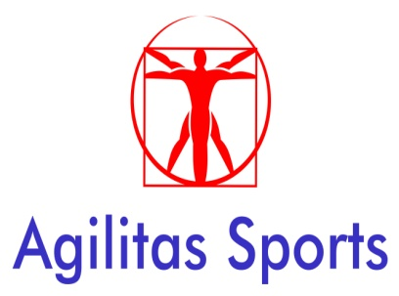

RISK ASSESSMENT

Organising body: Agilitas Sports Ltd on behalf of Lincolnshire South East School Sport Partnership.

Event: Primary School Competitions

Risk assessment carried out by: Rupert Gibson

Hazard | Who might be harmed | Existing Controls (or proposed controls in the case of a new activity) | *Risk rating with existing or proposed controls | Are risks adequately controlled Yes/No | If No, what further actions are required to reduce the risks
1. Debris on playing surface. | Participants | Inspection of surface prior to event. | 1 | Yes
2. Sport related injuries i.e. tripping, twisted ankles etc. | Participants | Schools should bring a designated first aider with adequate first aid resources.  Agilitas will provide emergency resources. | 2 | Yes
3. Inappropriate clothing & wearing of jewellery. | Participants | Schools informed of appropriate clothing to be worn. No jewellery to be worn, spot checks to take place by officials. Taping over of jewellery is not permitted. Correct sports specific safety equipment should be used e.g. shin guards must be worn for football. | 1 | Yes
4. Coach journey | Participants | Schools in undertaking their own risk assessments should adhere to LCC policies in terms of safe coach travel. These guidelines are set out in the ‘Safety in Outdoor Education brochure’. | 2 | Yes
5. Inadequate supervision ratios and pupil behaviour | Participants | Schools in undertaking their own risk assessments should adhere to LCC policies in terms of safe supervision ratios, appropriate consent forms and pupil behaviour guidelines. These guidelines are set out in the ‘Safety in Outdoor Education brochure’. Schools should send a minimum of 2 adults in case a pupil has to be taken to hospital by ambulance. | 2 | Yes
6. Unknown and uninvited adults attending | All | No spectators will be permitted unless they are assisting staff with teams in which case they will sign in with schools as additional members of staff. | 2 | Yes
7. Upset and distress to pupils and leaders by criticism, abuse or undue pressure. | Participants and Sports Leaders | Pupils and adults are required to follow our School Games Code of Conduct. Anyone breaking the code will be asked to leave the event. | 1 | Yes
8. The use of images in press and social media | All | Adults will be permitted to take photographs if they read and sign to say they agree to follow our policy. Schools should declare which pupils may not be photographed and these will wear a small sticker to help identification. | 1 | Yes
9. Other Safeguarding or Child Protection concerns | All | Any/all concerns should be raised at the earliest opportunity with the organiser from Agilitas Sports Ltd so it can be recorded and dealt with appropriately. | 2 | Yes

*Risk Rating = Likelihood of Occurrence x Severity of Harm (Not essential, can help in prioritising actions)

Likelihood of Occurrence | 1 Rare, 2 Unlikely, 3 Moderate, 4 Likely, 5 Almost Certain,
Severity of Injury | 1 Minor, 2 Moderate, 3 Significant, 4 Major, 5 Catastrophic

