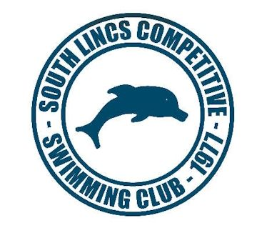

School Games News - Lincolnshire South East School Sport Partnership Swimming Gala
School Games offer the opportunities to participate in sport, compete against other teams and a chance for young people to volunteer and lead. The School Games aims to promote participation and competition but also instils the values of teamwork, determination, passion, honesty, self belief and respect.
On Wednesday 16th January we held our second swimming gala in association with South Lincs Competitive Swimming Club. It was a great opportunity for competitive swimmers to race against other schools but also for newer swimmers to enjoy their first big swimming gala and represent their schools.
Huge thanks go to Lorraine McCann, Marcy and Janet from the swimming club who helped run the races and Chris Allen and his Sports Leaders from The Priory School who did a great job timing all the swimmers.
Results:
Y3/4 |  | Y5/6
 |  | 5th | Whaplode
 |  | 4th | Linchfield
3rd | Langtoft | 3rd | Bourne Abbey
2nd | Market Deeping CP | 2nd | Market Deeping CP
1st | Linchfield | 1st | Langtoft

