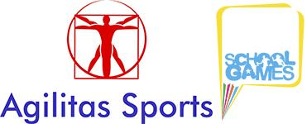

School Games
Lincolnshire South East – Goalball Competition 2018-19
On Tuesday 4th December we held our School Games Goalball event.
Goalball is played by athletes who are blind or visually impaired. It was invented in 1946 to help rehabilitate veterans who had lost their sight during the Second World War. All players must wear blindfolds at all times ensuring fair competition. Teams take it in turns to roll the ball (containing bells) towards the opposition goal line. The defending team listen carefully for the bell and try to block the ball and save the goals.
4 teams took part from Spalding Parish Church of England Day School, Whaplode and Weston St Mary.
Chris Allen and Sports Leaders from Spalding Priory School taught the pupils how to play and gave them some practice games before the competition began.
School Games Organiser, Rupert Gibson, was delighted with how the event went, “this competition highlights all that is great about the School Games. Sports Leaders getting a chance to volunteer and lead and young pupils learning a new sport, competing and representing their schools (many for the first time ever). MANY thanks to Spalding Priory for hosting the event”.
Results
- 4th Whaplode
- 3rd Weston St Mary
- 2nd Parish 'Z'
- 1st Parish 'A'

Rupert Gibson
School Games Organiser
Lincolnshire SE School Sport Partnership
Dedicated to improving the health and happiness of young people through Sport and PE
www.agilitassports.com
@AgilitasSports on Twitter, Facebook & Instagram

